Notes from the Dart Workshop
Finding Quiet Strength : The Sense of Time, Space, and Ease.
Professor Raymond Dart 1893-1988 was an Anthropologist and Anatomist. He had a deep interest in evolutionary movement and childhood development. He developed a series of movement patterns with the Murrays to explore the possibility of re-establishing balance and freedom in our structure and use. This became another way to observe our habits, by applying inhibition and direction, to find ease in ourselves and movement.
Dart was interested in how influential the cranial nerves are on our use. He noticed the influence of occlusion and malocclusion on our freedom in structure and ease in movement. He saw the effect of the dominance of the one side (left or right handedness) over the other. Another important observation was how the eyes lead movement and noted the significance of this terms of the influence on our primary control and capacity to turn and spiral in movement.
Dart work helps explore the sense of volume in the body; understanding the three planes: transverse (up and down) coronal, (front to back), median (side to side). We have evolved and grown and develop, in terms of dimension, back and down, forward and up and around. He also shows the relationship between the Axial + Appendicular structures of the skeleton sometimes thought of as primary and secondary influences on movement. He identified also the primary and secondary curves of the spine.
Dart was particularly known for his work on the skull of an Australopithecus skeleton which had many implications for understanding the journey to primate upright poise. He identified a change in location of the Foramen Magnum between this skull and earlier remains and proposed that this change was fundamental in the development of the relationship of the head and jaw to the spine.
F.M. Alexander 1869-1955 founder of The Alexander Technique; an enquiry into Psychophysical unity in stillness and movement. He identified his principles as ways to ‘re educate’ our sensory awareness and help us “learn how to learn”, and change.
In our workshop we will be working with stillness and movement and exploring opposition in direction; left to right, up and down, front to back, diagonals and spirals. Dart work helps us notice the connection to the primary sense of the Axial frame in relationship to the secondary Appendicular frame. We will also think about tensegrity, reversibility and the way noticing all these aspects can lead to a sense of wholeness. Observations will be made through balancing, information, experience with experimenting. When we are doing the movements, we are considering patterns vs sets, freedom versus fixing.
We will be working with our Alexander skills of quiet thought, touch, movement, breath, and non-doing to find an easier coordination. In this workshop we are going to use:
The Ready List: A chord of awareness (particularly to transition from one movement to another) helping us to think: “Where am I?” “What am I doing?” and “How am I doing it?”
Stop: to come to quiet and inviting the sense of being present.
See: Connecting to exteroception, the sense of space around us.
Breathe: Connecting to interoception, the sense of inner movement and inner tempo.
Soft and Tall: Connecting to Proprioception (volume) and Kinaesthesia (movement). The sense of height, width and depth = volume and easy movement being available. Being Grounded, Centred and Primary freedom all interconnected and embodied

Stages of Evolution:
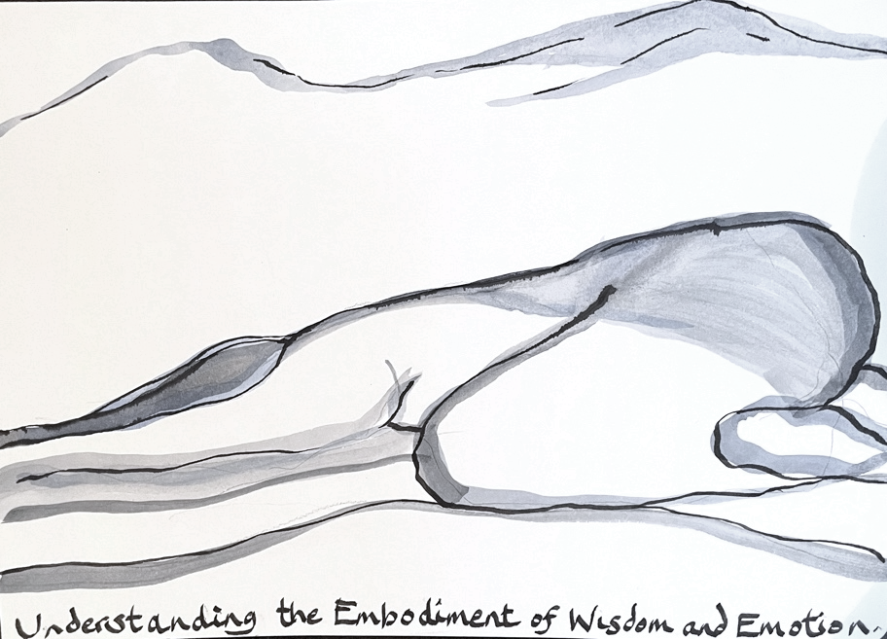
Cell
Nematode
Fish
Reptile/Bird
Mammal
Primate
Bipedal Human

Childhood Development:
Piscean – womb
Reptilian – 4-6 months
Mammalian – 6 months onwards
Primate – Springy legs
Bipedal – When we are walking upright

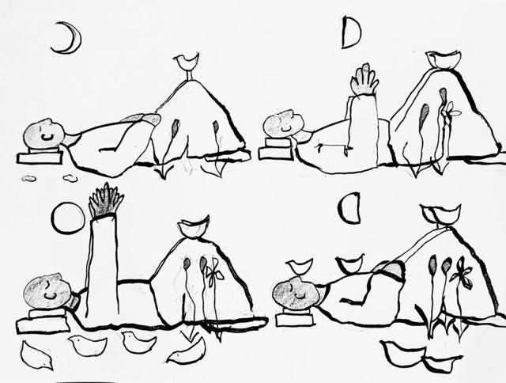

Childhood Reflexes are what we work through and let go of as we grow and develop. If we don’t, we may retain the reflex which can have implications for our use, mind, body and emotions. These are working towards (growing or developing) the primary sense which is balance.
Childhood Reflexes:
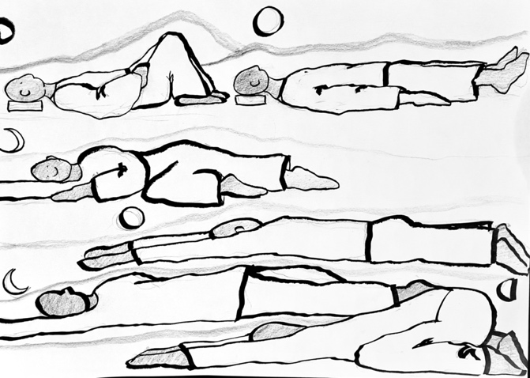
Moro
Rooting
Sucking
Righting
Tonic Labyrinth
Symmetric, tonic neck
Asymmetric tonic neck
Plantar and Palmer
Babinski
Spinal Galant
Reference: The Well-Balanced Child: Sally Goddard Blythe
Dart Work:
Squat to stand / Semi Supine / Supine /Prone / Child’s Pose/ Rolling / Chair work/ Crawling / Hands on the back of a chair and hands on the seat of the chair / Feet up onto the chair / Up onto the toes/ Wall Work/ Foetal / Pose of a Child / Crouch / Rotational Movement.….. These movement and poses help us to ask; “where am I, what am I doing and how am I doing it”? By being able to compare and contrast movement and stillness patterns with the principles, we can ask the question, “Can it be Easier?”

Working through these movements we can use the principles, to notice and regulate and let go of recruiting unnecessary tension.
We will be thinking through as we go along the ideas of how to let the work resonate with Emotional Intelligence and Embodied Awareness, with a sense of self-regulation balanced with a sense of co regulation: The ethos will be,
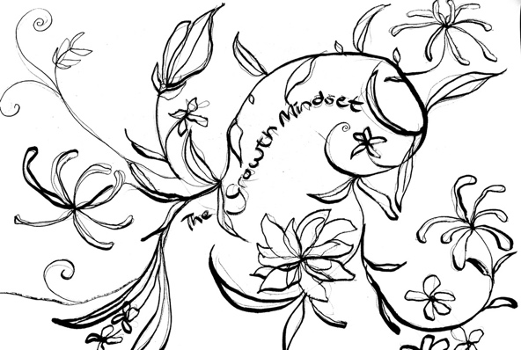

Connecting not Correcting:
CIA What can we Control, Influence, and just have to Allow.
The A Team ; Acknowledge, Accept, Allow, Act
Useful Books we will refer to:
Skill and Poise by Raymond Dart

The Well-Balanced Child by Sally Goddard Blythe

Dance and The Alexander Technique by Nettl-Foil and Vanier

Beginning at the Beginning: interview with Joan and Alex Murray

The Evolution of Movement by Robin Simmons

Anatomy Trains by Thomas Meyers
Finding Quiet Strength by Judith Kleinman
Useful Videos
Dart Procedures (Joan and Alex Murray)
https://youtu.be/KnYUvIRZe_o?si=XilcTrOI8IkFtxaA

